**Latent Class Modelling**

1. Latent class model for brand choice. First, fit a simple three class model with constant class probabilities. Then, fit the same model, but allow the class probabilities to very with age and sex. Finally, since we know that the true model is a three class model, we explore what happens when the model is over fit by fitting a four class model.  
   ?  
    **(1) Basic 3 class model.**  
     
   Nlogit ; Lhs = Choice ; Choices=Brand1,Brand2,Brand3,None  
   ; Rhs = Fash,Qual,Price,ASC4  
   ; LCM ; Pds = 8 ; Pts = 3 $  
     
   **(2) 3 class model. Class probabilities depend on covariates**  
     
   Nlogit ; Lhs = Choice ; Choices=Brand1,Brand2,Brand3,None  
   ; Rhs = Fash,Qual,Price,ASC4  
   ; LCM=Male,Age25,Age39 ; Pds = 8 ; Pts = 3 $  
     
    **(3) Overspecified model. 4 class model. The true model**  
     
   Nlogit ; Lhs = Choice ; Choices=Brand1,Brand2,Brand3,None  
   ; Rhs = Fash,Qual,Price,ASC4  
   ; LCM ; Pds = 8 ; Pts = 4 $

Other LCM Code:

NLOGIT ;

lhs=choice ;

choices=1,2,3

;LCM;Pds=12

;Pts=3

;Model: U(1) = ctype1*CT1 + ctype2*CT2 + jtask1*JT1 + jtask2*JT2 + pickup*FPS + health*FHC + training*FT + wage*Wage/

U(2) = ctype1*CT1 + ctype2*CT2 + jtask1*JT1 + jtask2*JT2 + pickup*FPS + health*FHC + training*FT + wage*Wage/

U(3) = asc3$

Links:

<http://pages.stern.nyu.edu/~wgreene/DiscreteChoice/Assignments/LabAssignment9.pdf>

<https://www.researchgate.net/topic/nlogit>

search “code in Nlogit for latent class model”

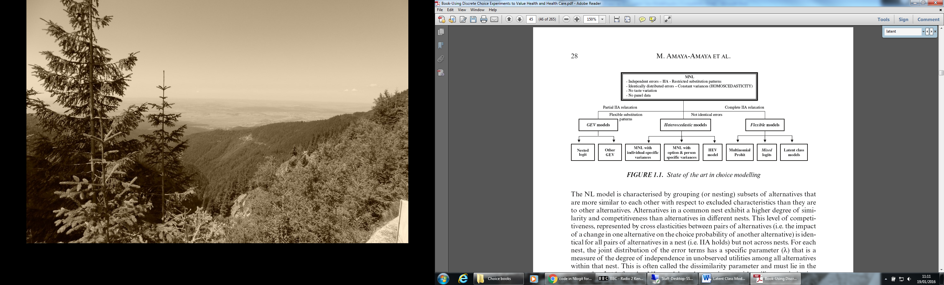

**; LCM [ = list of variables]** specifies latent class model. Optionally, specifies variables that

enter the class probabilities. (Command is also **LCLOGIT**.) Also used by

**PROBIT** and **BLOGIT**.

The essential form of the command for the latent class model is……

**LCLOGIT ; Lhs = dependent variable**

**; Choices = the names of the J alternatives**

**; Rhs = list of choice specific attributes**

**; Rh2 = list of choice invariant individual characteristics**

**; Pts = the number of classes $**

**N3.5.10 2K Latent Class Logit**

The 2K model is a particular latent class model in which there are simple constraints across the classes, but only one parameter vector used for the whole model. The model is set up as a latent class model with an additional specification:

**LCLOGIT ; Lhs = dependent variable**

**; Choices = the names of the J alternatives**

**; Rhs = list of choice specific attributes**

**; Rh2 = list of choice invariant individual characteristics**

**; Pts = the number of classes $**

In this form of the model, the number of points is specified as 102, 103, or 104, corresponding to whether

**N3.5.11 Latent Class Random Parameters**

The latent class random parameters model extends the latent class model. The essential command is

**LCRPLOGIT ; Lhs = dependent variable**

**; Choices = the names of the J alternatives**

**; Rhs = list of choice specific attributes**

**; Rh2 = list of choice invariant individual characteristics**

**; Fcn = definition of the random parameters part**

**; Pts = the number of classes $**